3A_ALL-GROUPS
WRITING PROFESSIONAL EMAILS – PRACTICE

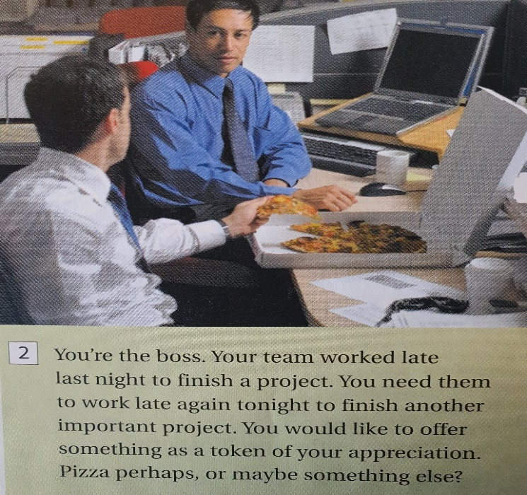
PAIR WORK = Read this situation and write the email
- Check spelling and grammar
- Then, give your email to another pair and read theirs.
- Write a reply.

To: ……………………………………………………………………..
From: …………………………………………………………………
Subject: ………………………………………………………………

………………………………………………………………………………………………………………………………………………………………………………………………………………………………………………………………………………………………………………………………………………………………………………………………………………………………………………………………………………………………………………………………………………………………………….
…………………………………………………………………………………………………………………………………………………………………………………………………………………………………………………………………………………………………………………………………………………………………………………………………………………………………………………………………………………………………………………………………………………………………………
…………………………………………………………………………………………………………………………………………………………………………………………………………………………………………………………………………………………………………………………………………………………………………………………………………………………………………………………………………………………………………………………………………………………………………
…………………………………………………………………………………………………………………………………………
…………………………………………………………………………………………………………………………………………………………………………………………………………………………………………………………………………………………………………………………………………………………………………………………………………………………………………………………………………………………………………………………………………………………………………

Reply to the email you have received

To: ……………………………………………………………………..
From: …………………………………………………………………
Subject: ………………………………………………………………

………………………………………………………………………………………………………………………………………………………………………………………………………………………………………………………………………………………………………………………………………………………………………………………………………………………………………………………………………………………………………………………………………………………………………….
…………………………………………………………………………………………………………………………………………………………………………………………………………………………………………………………………………………………………………………………………………………………………………………………………………………………………………………………………………………………………………………………………………………………………………
…………………………………………………………………………………………………………………………………………………………………………………………………………………………………………………………………………………………………………………………………………………………………………………………………………………………………………………………………………………………………………………………………………………………………………
…………………………………………………………………………………………………………………………………………
…………………………………………………………………………………………………………………………………………………………………………………………………………………………………………………………………………………………………………………………………………………………………………………………………………………………………………………………………………………………………………………………………………………………………………

